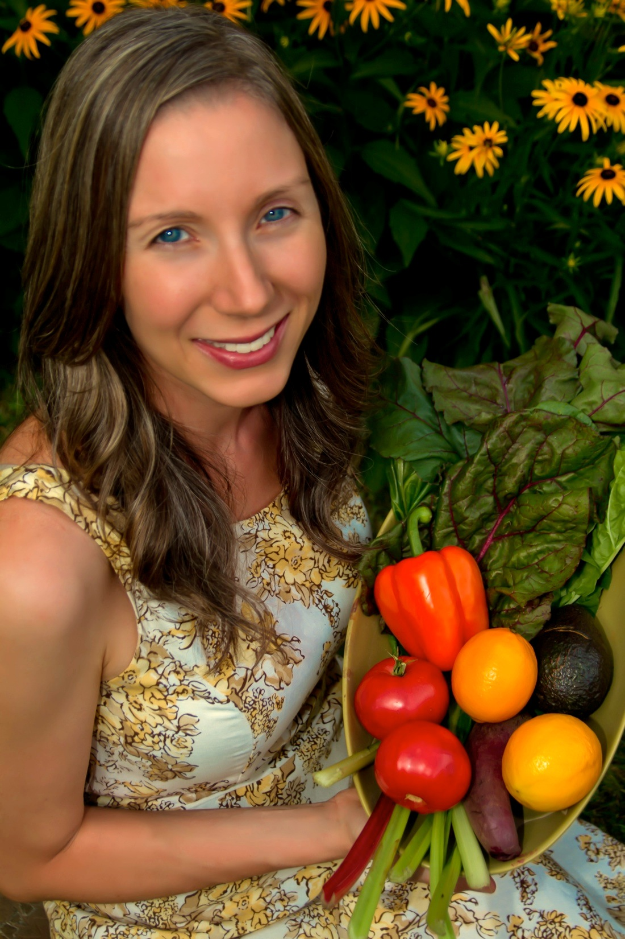

**Join Kristen for this life-changing workshop!**

**Date: Choose 1 day – Nov. 2 or Nov. 4 or Nov. 6, 2015**

**Location: The Spa at Norwich Inn, 607 West Thames Street, Norwich**

|  |
| --- |
|  |
|  |
|  |

**Time: Registration begins at 8 AM**

**You will:**

* **Learn how a whole food diet can heal and transform your life**
* **Know the benefits of whole foods**
* **Understand essential super foods**
* **Try a variety of super foods**
* **Learn mindful eating practices**
* **Learn essential stress-reducing techniques**
* **Be inspired!!**

**www.balancedlivingnow.com**

Kristen Werblow, M.A., is a Certified Professional Coach, an inspirational speaker, writer, and the founder of Balanced Living Now. She is also an Energy Leadership Index Master Practitioner, Reiki Master, and holds a Master’s Degree in Health and Healing, including the curriculum completion from the Institute of Integrative Nutrition.

Whole Foods for a Healthier

and More Energetic YOU!