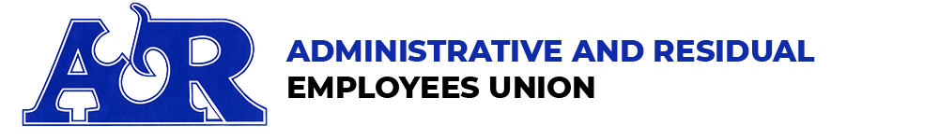

2023 A&R Union Municipal Election Questionnaire FOR MEMBERS

A&R is a diverse state union representing approximately 3,000 active State employees. Our members are in many professions including attorneys, paralegals, accountants, economists, planners and other state employment, all committed to enhance state services for the general public. The Committee on Political Education (COPE) follows public issues of importance to our members, and reviews candidates for endorsement. Donations on behalf of endorsed candidates are considered by A&R COPE PAC. Thank you for seeking our endorsement.
Please complete this questionnaire and return it either by email (office@andr.org) or mail to A&R Local 4200, 805 Brook Street, Rocky Hill CT 06067. Return date September 17, 2023.

Name: |  | Office Sought: |  |  | Party:
Address: |  |  |  |  | Town/District #:
City/Zip: |  | Email:
Home Phone: |  | Cell Phone:
Agency: |  | Job Title:
Do you have a Primary Election Opponent? □YES □ NO
Are you running as a Slate or as an Individual Candidate?
Are you a supporter of Collective Bargaining? □YES □ NO
Name the Committee your campaign is using for its funds: |  |  | Committee Treasurer:
Committee Address: |  |  | Committee City/Zip:
Campaign Contact Person: | Phone: |  |  | Email:
Return Deadline: Monday September 17, 2023 (responses received after this date might not be considered for endorsement by the COPE Committee). If you seek an endorsement for a primary, you must return this form with enough time for us to respond prior to the primary.

Additional Comments:

